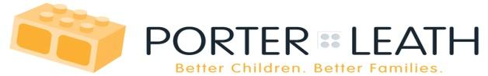

**Early Head Start Prenatal Program**

**Applications Accepted at**

**American Way Early Head Start**

**4207 American Way**

**Memphis, TN 38118**



**You must bring the following documents with you:**

· **Proof of pregnancy**

· **Your Health Insurance Card**

· **Your Photo ID**

· **Verification of Current Address**

**(MLGW bill, telephone bill, or copy of lease/mortgage payment )**

· **Verification of Income (3 recent check stubs, current W2/Tax return, Proof of Families First, SSI Disability or Child Support, if applicable)**

**You must have all documents in order to keep your appointment.**

**Prenatal Services offer:**

**Free Education & Supportive Services * Professionally Trained Staff \***

**Parents As Teachers Curriculum * Convenient in-home visits monthly** *

**Post-natal follow-up visit * Prenatal Support & Information**

For more information, call Sharon Burns-Scruggs,

Home Visitor @ 901-795-7544